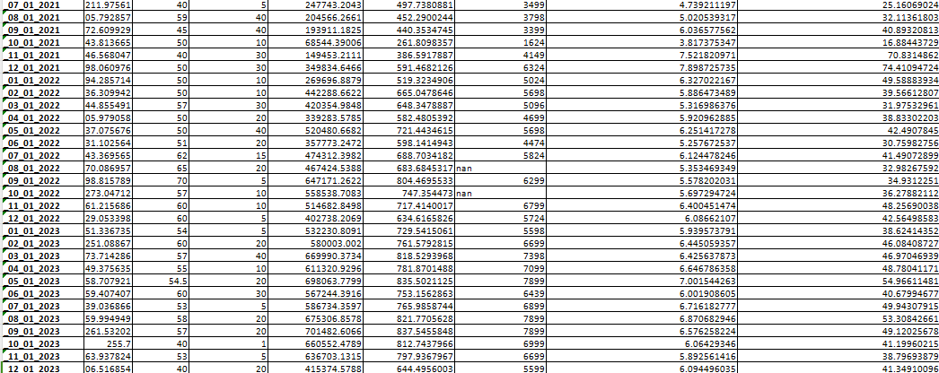**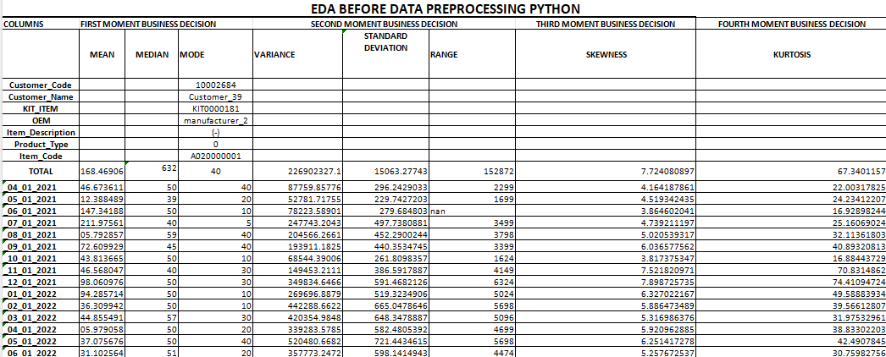STATISTICAL INSIGHT FOR PYTHON**

**PYTHON VISUALIZATION**

**HISTOGRAM FOR SKEWNESS AND KURTOSIS:**

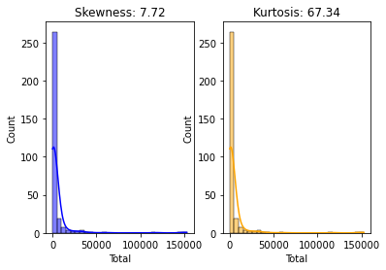

**Skewness (7.72):**

Positive skewness (greater than 0) indicates a right-skewed distribution, meaning the tail on the right side is longer or fatter than the left side.

In a business context, this might suggest that there are few extreme high values in the 'Total' column, leading to the rightward skewness.

**Kurtosis (67.34):**

Positive kurtosis (greater than 3) indicates heavy tails and a sharper peak than the normal distribution (leptokurtic).

In a business context, this could imply that there are outliers or extreme values in the 'Total' column, contributing to a distribution with heavy tails and a more peaked shape.

**BOX PLOT**

**BOX PLOT FOR TOTAL :**

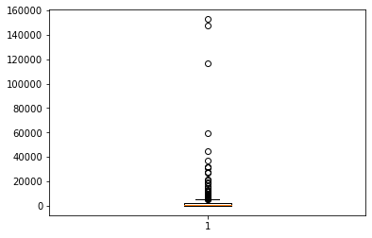

* The box plot shows the outliers are present in the total column.
* The Total column has extreme values present in them.

**BOX PLOT FOR OUTLIERS :**

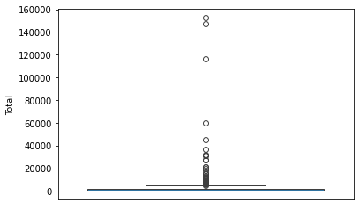

**BAR PLOT:**

**BAR PLOT FOR PRODUCT TYPE**

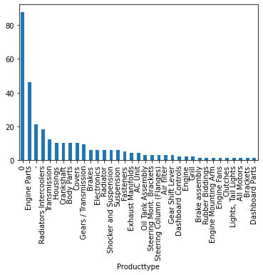

* The bar plot shows that engine parts are the highest amount of total product purchased
* The lowest product purchased is dashboard parts

**BAR PLOT FOR ITEM CODE**

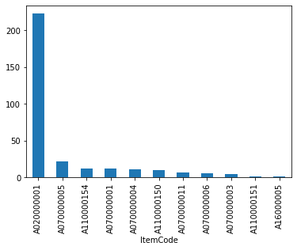

* The bar plot shows that a020000001 are the highest amount of total item purchased
* The lowest item purchased is a160000005

**HISTOGRAM:**

**HISTOGRAM PLOT FOR TOTAL :**

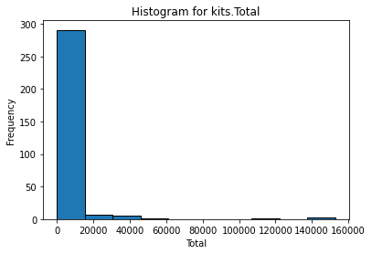

* The histogram plot shows that 0-18000 are the highest total item purchased
* The 18000-25000 are the second lowest range total item purchased

**HISTOGRAM PLOT FOR TOTAL TRANSFORMED :**

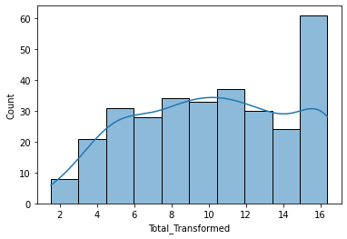

* The histogram plot shows that the total values are symmetrically distributed
* Where 15-16 is the highest amount of total
* And the value lines are gradually rising

**LINE CHART**

**LINE CHART FOR ITEM CODE :**

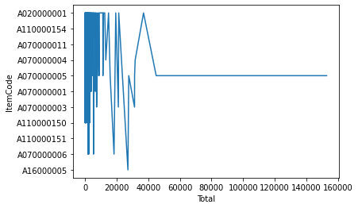

* The line plot shows that the total product values are range between 0-40000 as discussed before
* The a0200000001 is the highest and a16000005 are the lowest item purchased by the customer

**LINE CHART FOR ITEM CODE :**

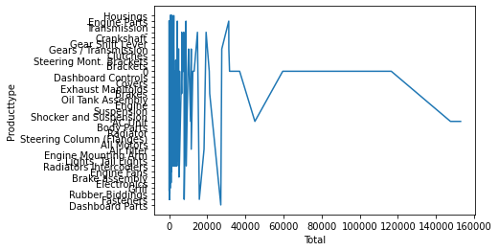

* The line plot shows that the housings product values are the highest amount of product range purchased by the customer
* Whereas the dashboard is the lowest part range purchased by the customer
* The line gets gradually decreased to a single line

**LINE CHART FOR ITEM CODE :**

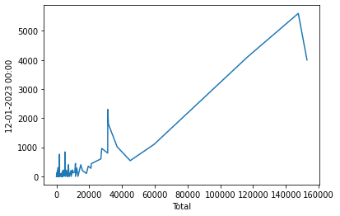

* The line plot shows that the on the date of 12-0-2023 the amount of product purchased by the customer on that particular date is the highest that goes upto > 5000 values

**LINE CHART FOR ITEM CODE :**

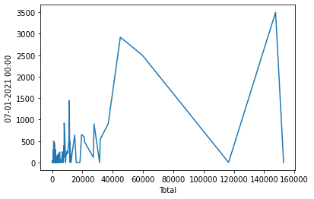

* The line plot shows that the on the date of 7-0-2021 the amount of product purchased by the customer on that particular date is the is higher and lower
* The min values is 0 and the max purchase goes upto 5000